**SECTION A-46 MARKS**

**Attempt** all **questions in this section.**

1. (a). Complete the following equations for the nuclear reactions.
   * 1.  + ………………………….. (01 mark)
     2. ${}_{95}^{241}{Am}$ + ${}_{2}^{4}{He}$ ${}_{97}^{243}{Bk}$ + ………………… (01 mark)
     3. ${}_{92}^{238}U$ + ${}_{0}^{1}n$ ${}_{93}^{239}{Np}$ + ………………… (01 mark)

(b). In an experiment, the rate of radioactive decay of bromine decreased by **25%** in **96** minutes. Calculate the **half-life** of bromine. (02 marks)

…………………………………………………………………………………………………………………………………………………………………………………………………………………………………………………………………………………………………………………………………………………………………………………………………………………………………………………………………………………………………………………………………………………………………………………………………………………………………………………………………………………………………………………………………………………………………………

1. An alkene **R**, diffuses through a porous partition in **2** minutes. Under similar conditions, the same volume of oxygen gas diffuses in **1.75** minutes.
2. (i). Calculate the **formula mass** of **R**. (01½ marks)

………………………………………………………………………………………………………………………………………………………………………………………………………………………………………………………………………………………………………………………………………………………………………………………………………………………………………………………………………………………………………………………………………………………………………………………………………………………………………………

(ii). Determine the **molecular formula** of **R**. (02 marks)

………………………………………………………………………………………………………………………………………………………………………………………………………………………………………………………………………………………………………………………………

1. Write equations to show how **R** can be **synthesized** from **propanone**. (02 marks)

………………………………………………………………………………………………………………………………………………………………………………………………………………………………………………………………………………………………………………………………………………………………………………………………………………………………………………………………………………………………………………………………………………………………………………………………………………………………………………………………………………………………………………………………………………………

1. In the manufacture of sulphuric acid, sulphur trioxide is **not** dissolved in water, but another solvent.
2. (i). State why water is **not** used as a solvent. (01 mark)

………………………………………………………………………………………………………………………………………………………………………………………………………………………………………………………………………………………………………………………

(ii).Write equation(s) to show the formation of sulphuric acid from sulphur trioxide gas. (03 marks)

………………………………………………………………………………………………………………………………………………………………………………………………………………………………………………………………………………………………………………………

1. Write equation for the reaction between sulphuric acid and hydrogen bromide. (01½ marks)

………………………………………………………………………………………………………………………………………………………………………………………………………………

1. (a) State **one** colligative property of a dilute solution other than depression of freezing point or elevation of boiling point of a solvent.

(01 mark)

………………………………………………………………………………………………………

(b) Ethane-1, 2-diol HOCH2CH2OH, is used as an antifreeze for water in car radiators. **Calculate** the **mass of ethane-1, 2-diol** that should be added to **1kg** of water to prevent it from freezing at **-10°C**.

(03 marks)

[Freezing point depression constant for water = **1.86°Ckgmol-1**]

…………………………………………………………………………………………………………………………………………………………………………………………………………………………………………………………………………………………………………………………………………………………………………………………………………………………………………………………………………………………………………………………………………………………………………………………………………………………………………………………………………………………………………………………………………………………………………



1. (a). State what is meant by the term **condensation polymerization**. (01 mark)

………………………………………………………………………………………………………………………………………………………………………………………………………………………………

(b). Write the **structural formulae** of the monomers of **nylon-6, 6**.

(01 mark)

………………………………………………………………………………………………………………………………………………………………………………………………………………………………

(c).Name:

1. **One natural polymer** that is formed by condensation polymerization. (01 mark)

………………………………………………………………………………………………………………………………………………………………………………………………………………

1. The **monomers** of the polymer in (c) (i). (0½ mark)

………………………………………………………………………………………………………………………………………………………………………………………………………………

(d).State **one** use of the polymer you have named in (c) (i). (0½ mark)

……………………………………………………………………………………………………………………………………………………………………………………………………………………

1. (a). State two properties in which chromium behaves as a transition element. (01 mark)

……………………………………………………………………………………………………………………………………………………………………………………………………………………………….

(b). Write the equation for the reaction that takes place when chromium (III) sulphate is dissolved in water. (01½ marks)

………………………………………………………………………………………………………………………………………………………………………………………………………………

(c). Magnesium ribbon was added to a solution of chromium (III) sulphate.

1. State what was observed. (01 mark)

………………………………………………………………………………………………………………………………………………………………………………………………………………

1. Write equation for the reaction that took place. (01½ marks)

………………………………………………………………………………………………………………………………………………………………………………………………………………

1. The graph below shows how the total vapour pressure of a mixture of water and nitrobenzene varies with temperature.



1. State the temperature at which the mixture boils at **760mmHg** pressure. (01 mark)

………………………………………………………………………………………………………………………………………………………………………………………………………………

1. The partial vapour pressure of nitrobenzene at the boiling point of the mixture is **20mmHg**.

Calculate the **percentage of nitrobenzene by mass** that will be obtained when the mixture is steam distilled at normal atmospheric pressure. (H = 1, C = 12, N = 14, O = 16) (04 marks)

………………………………………………………………………………………………………………………………………………………………………………………………………………………………………………………………………………………………………………………………………………………………………………………………………………………………………………………………………………………………………………………………………………………………………………………………………………………………………………………………………………………………………………………………………………………

1. (a). State the condition(s) under which the following conversions can be effected.



Conditions:

………………………………………………………………………………………………………………..……………………………………………………………………………………………………………….



Conditions:

………………………………………………………………………………………………………………..……………………………………………………………………………………………………………….

(b). Write a mechanism for the reaction leading to the formation of:



………………………………………………………………………………………………………………………………………………………………………………………………………………………………………………………………………………………………………………………………………………………………………………………………………………………………………………………………………………………………………………………………………………………………………………

1. Explain the following observations.
2. Silicon (IV) chloride is **hydrolyzed** by **water** while carbon tetrachloride is **not**. (03½ marks)

………………………………………………………………………………………………………………………………………………………………………………………………………………………………………………………………………………………………………………………………………………………………………………………………………………………………………………………………………………………………………………………………………………………………………………………………………………………………………………………………………………………………………………………………………………………………………………………………………………………………………………………………………………………………………………………………………………………………………

1. Lead (IV) chloride **exists** but lead (IV) bromide **does not**. (02 marks)

………………………………………………………………………………………………………………………………………………………………………………………………………………………………………………………………………………………………………………………………………………………………………………………………………………………………

**SECTION B-54 MARKS**

**Attempt** ANy **six questions in this section.**

1. Complete each of the following equations and write the suggested mechanism for the reaction.
2. 

**Mechanism**:

………………………………………………………………………………………………………………………………………………………………………………………………………………………………………………………………………………………………………………………………………………………………………………………………………………………………

1. **Mechanism**:

………………………………………………………………………………………………………………………………………………………………………………………………………………………………………………………………………………………………………………………………………………………………………………………………………………………………………………………………………………………………………………………………………

1. 

**Mechanism**:

………………………………………………………………………………………………………………………………………………………………………………………………………………………………………………………………………………………………………………………………………………………………………………………………………………………………

1. (a). State what is meant by the term **buffer solution**. (01 mark)

……………………………………………………………………………………………………………………………………………………………………………………………………………………………………………………………………………………………………………………………………………….

(b). Calculate the **pH** of the solution formed when **0.61g** of benzoic acid is dissolved in **1dm3** of a **0.02M** sodium benzoate. (02½ marks)

(**Ka** of benzoic acid = **6.3 x 10-5 moldm-3**)

…………………………………………………………………………………………………………………………………………………………………………………………………………………………………………………………………………………………………………………………………………………………………………………………………………………………………………………………………………………………………………………………………………………………………………………………………………………………………………………………………………………………………………………………………………………………………………………………………………………………………………………………………………………………………………………………………………………………..

(c). Explain what would happen to the **pH of the solution in (b)** if a few drops of the following reagents were added:

1. Potassium hydroxide solution. (03 marks)

………………………………………………………………………………………………………………………………………………………………………………………………………………………………………………………………………………………………………………………………………………………………………………………………………………………………………………………………………………………………………………………………………………………………………………………………………………………………

1. Hydrochloric acid. (02½ marks)

…………………………………………………………………………………………………………………………………………………………………………………………………………………………………………………………………………………………………………………………………………………………………………………………………………………………………………………………………………………………………………………………

1. (a). When **0.1g** of aluminium chloride was vaporized at **350°C** and pressure of **1atmosphere**, **19.2cm3** of vapour was formed.
2. Calculate the **relative molecular mass** of aluminium chloride. (02 marks)

………………………………………………………………………………………………………………………………………………………………………………………………………………………………………………………………………………………………………………………………………………………………………………………………………………………………………………………………………………………………………………………………………

1. Write the **molecular formula** of aluminium chloride in the gaseous state at **350°C**. (Al = 27, Cl = 35.5) (01 mark)

……………………………………………………………………………………………………………………………………………………………………………………………………

(b). Aluminium chloride is normally contaminated by traces of iron (III) chloride.

1. Name **one reagent** that can be used to detect the presence of iron (III) ion in a contaminated solution of aluminium chloride.

(01 mark)

……………………………………………………………………………………………………………………………………………………………………………………………………

1. State what would be observed if the contaminated aluminium chloride solution was treated with the named reagent in (b) (i). (0½ mark)

………………………………………………………………………………………………………………………………………………………………………………………………………………

1. Write equation for the reaction leading to the observation you have stated in (b) (ii). (01½ marks)

………………………………………………………………………………………………………………………………………………………………………………………………………………

(c). Water was added drop wise to aluminium chloride.

1. State what was observed. (01 mark)

………………………………………………………………………………………………………………………………………………………………………………………………………………

1. Write equation for the reaction that took place. (01½ marks)

……………………………………………………………………………………………………………………………………………………………………………………………………………..

(d).State **one use** of aluminium chloride in organic synthesis. (0½ mark)

……………………………………………………………………………………………………………………………………………………………………………………………………………………………………………………………………………………………………………………………………………….

1. (a). Draw the structure and name the shape of each of the species in the table below. (04½ marks)



(b). Write equation for the reaction between:

1. Boron trifluorude and ammonia. (01½ marks)

…………………………………………………………………………………………………………………………………………………………………………………………………………

1. Tin (II) chloride and iron (III) ions. (01½ marks)

…………………………………………………………………………………………………………………………………………………………………………………………………………

1. Acidified potassium iodide solution and aqueous sodium chlorate (V) solution. (01½ marks)

…………………………………………………………………………………………………………………………………………………………………………………………………………

1. (a). Write:
2. Equation for the **ionization** of methanoic acid in water.

(01½ marks)

…………………………………………………………………………………………………………………………………………………………………………………………………………

1. The **expression** for the acid dissociation constant Ka, for methanoic acid. (01 mark)

………………………………………………………………………………………………………………………………………………………………………………………………………………

(b). The molar conductivities of some electrolytes at infinite dilute at **25°C** are given in the table below.

|  |  |
| --- | --- |
| Electrolyte | molar conductivity at infinite dilution (**Scm2/mol)** |
| Sodium chloride | 113.0 |
| Sodium methanoate | 101.0 |
| Sodium hydroxide | 225.2 |
| Hydrochloric acid | 397.8 |

Calculate the **molar conductivity** of methanoic acid at infinite dilution. (03 marks)

………………………………………………………………………………………………………………………………………………………………………………………………………………………………………………………………………………………………………………………………………………………………………………………………………………………………

(c). The molar conductivity of a **0.05M** methanoic acid solution is **24.328Scm2/mol** at **25°C**.

Calculate the:

1. Degree of **ionization** of methanoic acid at **25°C**. (01½ marks)

……………………………………………………………………………………………………………………………………………………………………………………………………………………………………………………………………………………………………………………………………………………………………………………………………………………

1. Dissociation constant **Ka** of methanoic acid at **25°C**.(02 marks)

……………………………………………………………………………………………………………………………………………………………………………………………………………………………………………………………………………………………………………………………………………………………………………………………………………………

1. Name **one** **functional group** that can be identified using each of the following reagents. In each case state what would be **observed** and write **equation** for the reaction that would take place:
2. Bromine water:

**Functional group**. (01 mark)

…………………………………………………………………………………………………………………………………………………………………………………………………………………….

**Observation.** (01 mark)

…………………………………………………………………………………………………………………………………………………………………………………………………………………….

**Equation**. (01 mark)

…………………………………………………………………………………………………………………………………………………………………………………………………………………….

1. 2, 4-dinitrophenyl hydrazine.

**Functional group**. (01 mark)

……………………………………………………………………………………………………………………………………………………………………………………………………………………

**Observation.** (01 mark)

…………………………………………………………………………………………………………………………………………………………………………………………………………………….

**Equation.** (01 mark)

……………………………………………………………………………………………………………………………………………………………………………………………………………………

1. Sodium carbonate.

**Functional group.** (01 mark)

……………………………………………………………………………………………………………………………………………………………………………………………………………………

**Observation.** (01 mark)

……………………………………………………………………………………………………………………………………………………………………………………………………………………

**Equation.** (01 mark)

……………………………………………………………………………………………………………………………………………………………………………………………………………………

1. During the extraction of copper from copper pyrites, copper pyrites is crushed and agitated with water/oil mixture. Compressed air is bubbled through the mixture which is then filtered, roasted and finally impure molten copper is obtained.
2. State the role of:
3. Oil. (01 mark)

………………………………………………………………………………………………………………………………………………………………………………………………………………

1. Compressed air. (01 mark)

………………………………………………………………………………………………………………………………………………………………………………………………………………

1. Write equation for the reaction that occurs when copper pyrites is roasted. (01½ marks)

……………………………………………………………………………………………………………………………………………………………………………………………………………………

1. Explain briefly how impure copper can be refined. (04 marks)

………………………………………………………………………………………………………………………………………………………………………………………………………………………………………………………………………………………………………………………………………………………………………………………………………………………………………………………………………………………………………………………………………………………………………………………………………………………………………………………………………………………………………………………………………………………………………………………………………………………………………………………………………………………………………………………………………………………………………………………………

1. Explain why it is advantageous to have a sulphuric acid manufacturing plant near a copper extraction plant. (01½ marks)

………………………………………………………………………………………………………………………………………………………………………………………………………………………………………………………………………………………………………………………………

1. (a). State what is meant by the term:
2. Order of a reaction. (01 mark)

………………………………………………………………………………………………………………………………………………………………………………………………………………………………………………………………………………………………………………………

1. Half-life of a reaction. (01 mark)

………………………………………………………………………………………………………………………………………………………………………………………………………………………………………………………………………………………………………………………

(b). The table below shows the kinetic data obtained for the hydrolysis of methyl ethanoate in acidic media.

|  |  |  |  |  |  |  |
| --- | --- | --- | --- | --- | --- | --- |
| [CH3COOCH3](mol/dm3) | 0.241 | 0.161 | 0.109 | 0.073 | 0.046 | 0.034 |
| Time (minutes) | 0 | 60 | 120 | 180 | 240 | 320 |

Plot a graph of **concentration** of methyl ethanoate **against time**.

1. arks)



(c).Use the graph in (b) above to determine the:

1. Half-life of the reaction. (01½ marks)

………………………………………………………………………………………………………………………………………………………………………………………………………………………………………………………………………………………………………………………………………………………………………………………………………………………………………………………………………………………………………………………………………

1. Order of the reaction with respect to CH3COOCH3.Give a reason for your answer. (01 mark)

………………………………………………………………………………………………………………………………………………………………………………………………………………

(d).Calculate the **rate constant** and indicate its **units**. (01½ marks)

………………………………………………………………………………………………………………………………………………………………………………………………………………………………………………………………………………………………………………………………………………………………………………………………………………………………………………………………

* 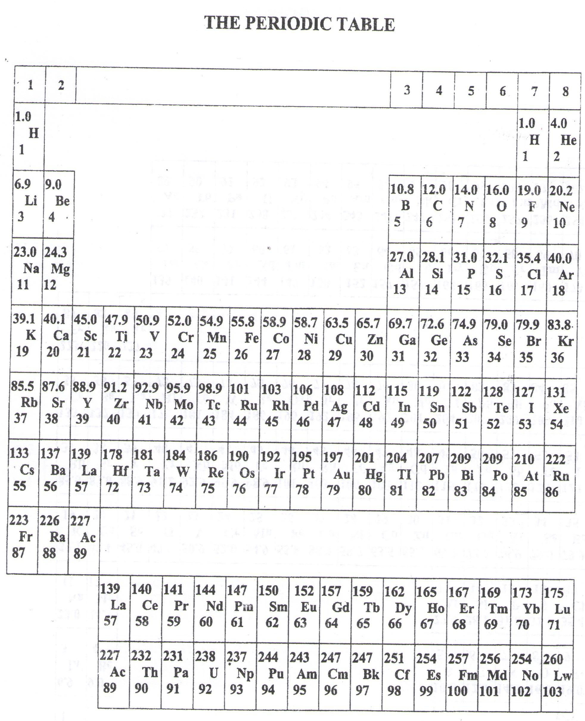 ===END===

WELCOME TO SENIOR SIX, YEAR 2018

This is the last page of the printed paper, Page 20